**FLOWER SPECIES PREDICTION**

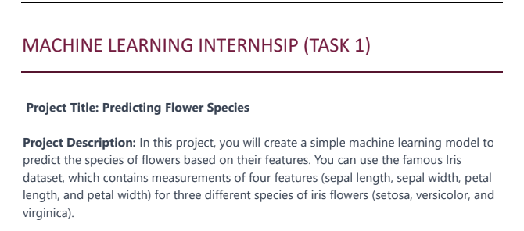

The model is created for the above task which asks user input for sepal length, sepal width, petal length and petal width and try to predict which species of iris the above measurements fall into. It also provides the user with accuracy and precision score of all the algorithms that are used for prediction.

**TOOLS & LIBRARIES:**

Python 3.8+

Numpy

Pandas

Matplotlib

ScikitLearn

Google colab or Jupyter Notebook

**SCREENSHOTS OF THE TASK:**

